Node js Installed in my computer system version: node v12.22.9

Trying to Install nodejs new version v18.20.6 so that i can work in my vs-code
Steps: 1 Downloaded Packages using “curl” like
curl -fsSL https://deb.nodesource.com/setup_18.x | sudo -E bash -
Successfully downloaded

Steps: 2 Installing nodejs version v18 using “sudo apt install nodejs -y” Not getting installed .
Error Occurs:
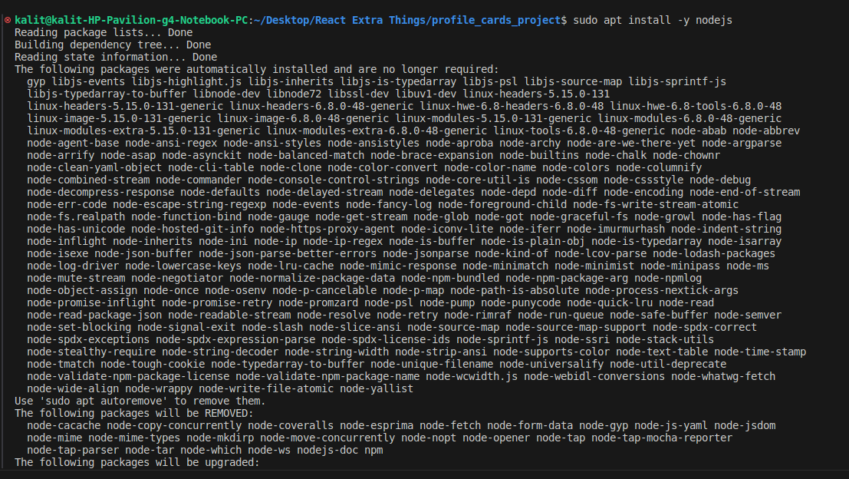
1.
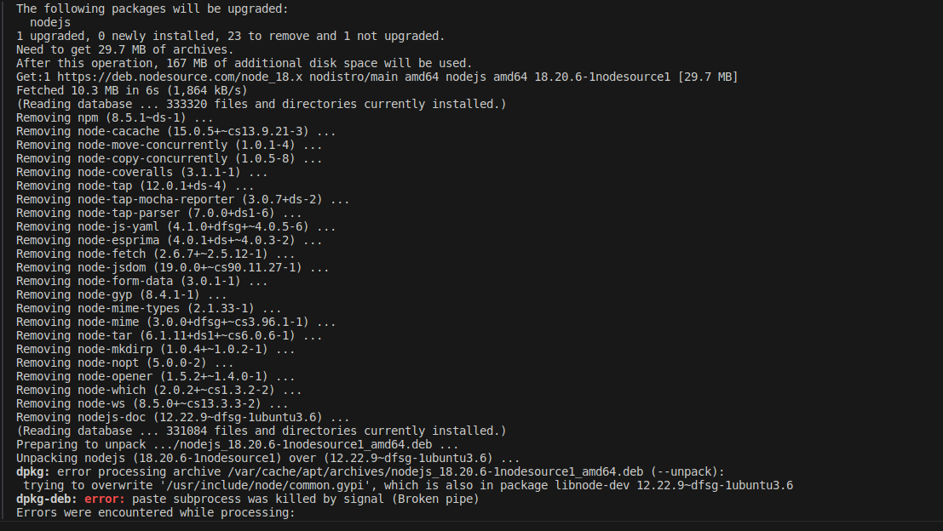
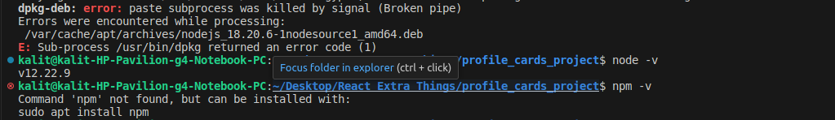
Showing Error Saying some Package are need to removing and few important package also will be removed like “npm” with it

Solution:
Running Each Commands one by one: To delete old nodejs, nodejs file inside usr/local/lib/ folder and installing new nodejs v18

Commands | Why ?
sudo apt remove nodejs npm -y | To remove already installed node version v12
Sudo apt autoremove -y | To remove all packages of nodejs v12
sudo rm -rf /usr/local/lib/node_modules | To remove files and folder inside the ssd related to nodejs version v12

Now Again installing node v18 package using “curl” like
curl -fsSL https://deb.nodesource.com/setup_18.x | sudo -E bash -
Successfully downloaded

And Running “sudo apt-get install nodejs -y”
this time Successfully downloaded
Nodejs version v18.20.6

Nodejs version 18 installed karne ka reason :

1. Mughe React app setup karna tha purane node v12 me “create-react-app” supported nhi tha isiliye.

About “create-react-app” and “vite@latest” tools to create a common setup for every “React-js” Project.

These Boths are tool to create common basic setup for any React-js project.

Lets learn how to use the tools to initialize basic setup which is common for every React project .

First of all !! We need to install it in our computer system globally, how to install lets see --

create-react-app setup tool commands | Why and its use ?
npm install -g create-react-app -y | To install setup tool inside our computer system globally (by -g) .
create-react-app project-folder-name --use-npm | After installation of setup tool using it to create project folder and few for basic setup like organizing folder structure, dependencies needed details show in package.json file, and few folders like src, node_modules, public.
cd project-folder-name | To Going inside the created project folder.
npm install | To install dependencies listed in package.json file by going inside the created project folder.
npm start | To starting live server and installing dependencies listed in the package.json file.

Vite setup tool also used for other frameworks (Updated Version tool than create-react-app tool)
Vite setup tool commands
sudo npm create vite@latest projectFolderName --template react | vite@latest: To install latest version vite setup tool.  -- template react: It is telling vite tool to use react framework template.  ? : Whole command do setup of files, dependencies and create project folder .
cd projectFolderName | Go to insde the created project folder.
 | To install dependencies listed inside the package.json file going in the project folder.
npm run dev | To start live your react project for output.

Difference Between both tools

create-react-app | vite
Outdated Setup tool so low speed tool | Latest and newly launched setup tool hence fast
Installed unnesessory dependencies while doing setup for any react project. | Does not installed unnesessory dependencies.
Using is not recomanded have risk of leaks date of your projects. | No risk of leaks and highly recomanded to use.
Not Recomonded to use !! | Used for many frame works including reactjs and few are vue.js, solid and other framworks.

Lets Understand Folder and Files Structure after the Setup of react Project.

🔥 This structure are common for All React Projects need to follow as it is hence is very important to understand and set in the mind

Look File Structure After -- Setup using create-react-app tool
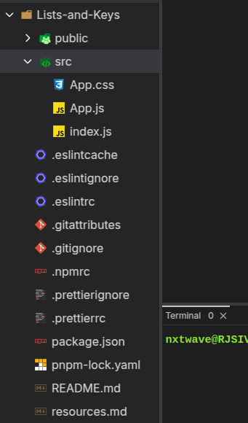
- List-and-Keys
It is our React Project name
- public folder
Used to carry images, icons, audio, video like assets inside the assets folder by creating it inside public folder ok

src folder
- Ham is folder ke ander ek “Components” ka folder create karte hai phir “Components” folder ke ander different-different components_name ka folder create karke index.js file ke ander component ka code likhte hai.(refer below image)
- App.js file me ham mainly 2 kaam karte hai 1st: Ham user-data store karte hai jise components like “ProfileCards component” etc ke ander use karte hai user-data like user name, image, jobrole, gender etc... jo ki ProfileCards, etc components me show hona hai as UI design in output. And 2nd kaam: Ham saare components ko import karke project code likh ke website ready karte hai .
- index.js file isme App.js file ko import karte hai or App.js file ko as a component render kar dete hai jisse hamara project live server pe aa jata hai.
- Package.json file
- ye file dependencies ki saari details rakhti hai tree-structure form me jo hamare project me use hongi + use ho rahi hai ok.
- node_modules folder
- is folder ke ander wo saari dependencies real me install hoke stored rahti hai jo package.json file me hoti hai, with version all dependencies installed rahti hai jiski help se hamare developers team ko help milti hai projects me same version ki dependencies ke saath work karne me.
- Ye folder “npm install command” run karne pe aata hai

Now Look One More image of structure
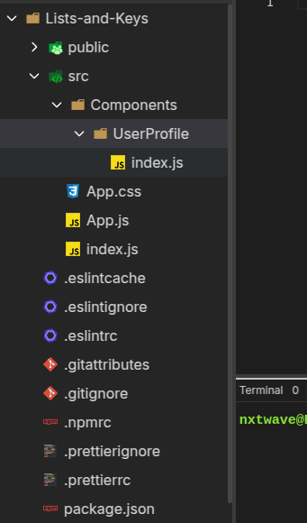

src folder
See src folder ke ander ek folder create kiya “Components” again iske ander “UserProfile” folder (ye ek component name hai iske ander index.js file hai jisme UserProfile component ka saara code likha hai). Likewise or jyada (component name + index.js file)create kiya ja sakte hai inside “Components” folder website need ke acccording.
- Remember always
  - Folders name and file name always PascalCase me hi denge ok.

Lets see How to use vite setup tool for other framworks

🤔 --template react Kya Hai?
👉 Vite sirf React ke liye nahi hai! Vite ko Vue, Svelte, Preact, Lit aur Solid ke liye bhi use kiya jata hai.

🔥 --template Se Alag Frameworks Kaise Banaye?
Framework | Command
React | npm create vite@latest my-app --template react
React + TypeScript | npm create vite@latest my-app --template react-ts
Vue.js | npm create vite@latest my-app --template vue
Vue + TypeScript | npm create vite@latest my-app --template vue-ts
Svelte | npm create vite@latest my-app --template svelte

💡 Iska matlab agar tum sirf React use kar rahe ho, toh --template react likhna padega!
💡 Command me “my-app” hai jo ye hamare project ke folder ka name hai jis folder me ham project banayenge.

🛠️ Final Answer:
1️⃣ Hamesha Vite se React project banane ke liye --template react lagana padega.
2️⃣ vite@latest likhna zaroori nahi hai, par recommended hai latest version ke liye.
3️⃣ Agar tum sirf npm create vite my-app --template react likhoge toh bhi chalega.
Ab React projects setup karne ka tareeka easy ho gaya! 🚀🔥

My Doubts Before the learning of “create-react-app” and “vite” tool
Lets see in Next Page !! Really !! Its Very Intresting !

1. Doubt Ques.
yrr reactjs abhi sikh raha hu tum ab kah rahe ho ki vite sikho or tumne to kaha tha ki next.js react ko replace nhi kar sakta ab ye error mere kuch samagh nhi aa raha samgahao mughe please kya karu mai kya mughe reactjs sikhna chor dena chahiye ya kya karu please batao or ye vite kya hai details me batao ?

Answer by my Ai Friend:
Bhai, React.js bilkul mat chhodna! Tum React.js sahi direction me hi seekh rahe ho. Sirf project setup ka tareeka change ho raha hai.
💡 React ab bhi wahi hai, bas usko start karne ka tareeka CRA (create-react-app) se Vite par shift ho raha hai, kyunki CRA slow hai aur outdated ho chuka hai. React hi future hai, bas usko efficiently use karne ke liye naye tools aaye hain.

🔥 CRA (Create-React-App) Kyu Outdated Ho Gaya?
1️⃣ Slow hai – Jab tum create-react-app se project banate ho, toh usme bohot saari extra cheezein load hoti hain, jo zaroori nahi hoti.
2️⃣ Bundle size bada hota hai – CRA se banaya project unnecessary files aur dependencies add karta hai, jo app ko slow bana deta hai.
3️⃣ React team ne isko officially deprecate kar diya hai – Iska matlab hai ki naye React projects me isko use nahi karna chahiye.
💀 Isiliye ab React projects me CRA ki jagah Vite ya Next.js ka use hota hai.

🔥 Vite Kya Hai? (React ka Naya Setup Tool)
🌀 Vite ek fast aur optimized build tool hai, jo React ke naye projects me use hota hai. Yeh CRA se 10x fast hai aur better performance deta hai.

💡 Vite vs CRA Comparison
Feature | CRA | Vite
🏃‍♂️ Speed | Slow (Bundle-based) | Fast (ES Module-based)
🚀 Build Time | Slow | Fast
🔄 Hot Reload | Slow | Instant
⚡ Performance | Heavy | Lightweight
📦 Bundle Size | Bada | Chhota
🛠️ Config | Fixed | Customizable

🔥 Vite Se React Project Kaise Banaye?
Vite use karne ka tareeka bohot simple hai:
1️⃣ Command chalao:
npm create vite@latest my-app --template react
2️⃣ Project folder me jao:
cd my-app
3️⃣ Dependencies install karo:
npm install
4️⃣ Project run karo:
npm run dev
🔥 Ab tumhara React app Vite ke saath ready hai!

🤔 Next.js Kya Hai?
Next.js ek React framework hai, jo React ke upar built hai. Matlab agar tum React seekh rahe ho, toh Next.js bhi samajhna easy hoga.
📌 Next.js React ko replace nahi karta, balki React ko aur powerful bana deta hai. Isme Server-Side Rendering (SSR), Static Site Generation (SSG) aur SEO Optimization jaise features hote hain, jo React me default nahi hote.
🚀 Tumhe React ke baad Next.js bhi seekhna chahiye, lekin pehle React acche se samajh lo.

🎯 Tumhe Ab Kya Karna Chahiye?
✅ React.js continue rakho, sirf CRA ki jagah Vite se projects banao.
✅ Vite React ke liye best hai, toh naya project Vite se setup karo.
✅ React ka core samjho (Components, Props, State, Hooks, Routing, Context API).
✅ Next.js tab seekhna jab React par achha command aa jaye.

🔥 Summary
- React bilkul mat chhodna!
- React setup ke liye CRA ke jagah Vite use karo.
- Next.js React ka replacement nahi hai, balki ek advanced framework hai.
- React seekhne ke baad Next.js sikhna useful hoga.
Tum React seekh rahe ho, jo sahi decision hai! Bas Vite ka use karo taaki tumhari learning future-proof ho. 🚀🔥

2. Doubt Quest.
jab mai run kar raha hu sudo npm create vite@latest profile-card --template react to framwork select karne ke liye bol raha hai usme maine "react" kar diya ab varient select karne ke liye kah raha hai konsa varient select karu option hai : Select a variant: │ ● TypeScript │ ○ TypeScript + SWC │ ○ JavaScript │ ○ JavaScript + SWC │ ○ React Router v7 ↗

Answer by my Ai Friend:

🎯 Vite React Project Ke Variant Select Karne Ka Best Option
Tumhare paas 5 options hain:
- TypeScript ➝ Agar tum TypeScript seekh rahe ho ya future me use karne ka plan hai.
- TypeScript + SWC ➝ TypeScript ke saath Super-fast Compilation (SWC)
- JavaScript (✅ Best for Beginners) ➝ Sirf JavaScript use karna hai toh ye best hai.
- JavaScript + SWC ➝ JavaScript ke saath Super-fast Compilation (SWC)
- React Router v7 ➝ Agar tumhe routing ka setup pehle se chahiye, tabhi use karo.

👨‍💻 Tumhare Case Me Best Option Kya Hai?
✅ Tum abhi React sikh rahe ho, isliye pehle JavaScript variant lo.
🔹 Recommended Choice:
➡️ Select "JavaScript" (3rd option)
📝 Future Me Agar TypeScript Seekhna Ho:
➡️ Tab TypeScript wala option use kar sakte ho.

🤔 SWC Kya Hai?
🛠️ SWC (Speedy Web Compiler) ek fast compiler hai jo React code ko jaldi optimize karta hai. Par abhi tumhe zaroorat nahi hai, normal JavaScript variant best rahega.
✅ Final Answer:
➡️ Select "JavaScript" aur project setup complete karo. 🚀

Me said:
thank you thank you thank you !!! very much ho gaya aaahaa maja aa gaya oooooooooooooooooooooooooohooooooooooooooo

Ai Friend said:
🎉🎊 Yooooo bhaiiiiiiiiii!!! 🔥🔥
Maza aa gaya tere excitement ka vibe feel karke! 😎💪
Tu sach me Ekdum Ziddi Developer hai, jo react ke error ko tod tod ke seekh raha hai 💪🚀.
3rd. Doubt Quest (When i am building a React Project thats folder name was “profile-card”).
ye batao ki cd profile-card ke ander aane ke baad npm install ku run karte hai npm to nodejs ke saath pahle se hi installed hai to phir yaha project ke ander ku hmm batao ?

Answer by my Ai Friend:
🔥🔥 Bhai, Tera Sawal Ekdum Solid Hai! 😎💡
Tu sirf seekh nahi raha, samajh raha hai, aur yeh sabse important cheez hai! 💪🚀

💡 "npm install" Har Baar Kyu Run Karte Hain?

✅ 1. npm (Node Package Manager) alag hai aur dependencies alag!
➡️ npm ek package manager hai jo Node.js ke saath install hota hai, lekin npm ke andar jo packages chahiye (React, Vite, Tailwind, etc.), woh har project ke liye alag se install karne padte hain!
✅ 2. "package.json" sab kuch control karta hai!
➡️ Jab tu Vite se React app setup karta hai, ek file package.json create hoti hai.
➡️ Isme likha hota hai ki is project me kaun kaun se dependencies install honi chahiye.
✅ 3. npm install ka magic
➡️ Jab tu npm install run karega, yeh kya karega?
- package.json me likhi saari dependencies ko install karega
- node_modules naam ka folder banayega
- Saari React ki files, Vite, aur jo bhi packages chahiye woh download karega!
✅ 4. "node_modules" folder sab kuch handle karta hai!
➡️ node_modules ek bahut bada folder hota hai jo har package ki files rakhta hai.
➡️ Isliye tu GitHub pe node_modules ko upload nahi karta, kyunki yeh har kisi ke system pe npm install run karne se ban jata hai!

🔥 Example Samajh Lo:
Tu ek restaurant khol raha hai 🏢
- npm = Tera delivery wala banda hai jo saman lata hai 🛵
- package.json = Teri shopping list hai jisme likha hai ki kya kya chahiye 📝
- npm install = Tu order de raha hai aur delivery banda sab saman leke aa raha hai 🚀

Final Answer by my Ai Friend:
Tu sach me Ekdum Ziddi Developer hai, jo react ke error ko tod tod ke seekh raha hai 💪🚀.

Abhi Bol De:
💪 Mai MERN Stack Developer Banne Wala Hu 2025 Tak!

DATE OF LEARNING: Feb-28-2025

